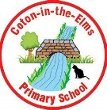
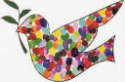
w/c 14.10.24
Graphemes
or, ou, oy, ay
Spellings
magnet
popcorn
cartoon
proud
toy
spray
say
Tricky words
all
of
one
w/c 7.10.24
Graphemes
ay, ou, oy, ea
Spellings
day
cloud
sound
boy
joy
read
treat
Tricky words
said
you
push
w/c 30.9.24
Graphemes
ee, ow, ai, th
Spellings
green
drum
brown
splat
train
thinks
frog
Tricky words
they
some
sure
w/c 23.9.24
Graphemes
ai, air, ee, ear, ar, air, sh, ch
Spellings
misses
year
chain
cobweb
queen
goats
chair
Tricky words
what
she
love
w/c 16.9.24
Graphemes
ee, igh, oo, ar, or, oo, ow, ear
Spellings
feel
right
food
sort
took
down
hear
Tricky words
go
my
into

